**Team Members**

Azamat Truscott

Riley Grant

Mike Thomas

Matt Gurney

Matthew Dick

Daniel Poulson



**Fusion**

**System Requirements Document**

Issue 1.0

Issue Date: 21/10/2020

**Summary of Changes**

|  |  |  |  |
| --- | --- | --- | --- |
| **Change Incorporated** | **Date of Incorporation** | **Section of document** | **Issue** |
| First Issue | N/A | N/A | 1.0 |

This table states any resulting changes made to this document.

**Contents**

1. **Document Purpose 4**
2. **Change Control 4**
3. **Scope 5**
4. **System Requirements 6**

1. Document Purpose

This is the System Requirements Document (SRD) for the Fusion Sensor Network (FSN) system.

It outlines the functional top-level requirements of the FSN, which were derived by Fusion for the business need outlined in Section 2.

This SRD is at Issue 1.0, and the functional top-level requirements within it are in their first baseline.

* 1. Change Control

If, at any stage during the FSN system maturation the SRD or the requirements need amending, the SRD will be up issued following a formal Change Control method.

The method is as follows:

* + - 1. Each team member within Fusion would discuss the required change(s) to the SRD and/or the FSN Requirements and agree on its functional and financial feasibility of incorporation. A record of the discussion would be captured within the Fusion Meeting Minutes.
      2. If the majority of the team (Fusion) agree to the incorporation of the change(s), this SRD will be up issued, and the requirements’ baseline ascend.
      3. At the start of the SRD, there is a “Summary of Changes “ table to show which changes have been made since the first issue; the date of the changes; which pages of the SRD have been affected as a result of the change; and the document’s issue number at the time of the change incorporation.

1. Scope

The scope of the SRD is to derive the FSN system requirements to serve as a baseline prior to the initial system design, development and testing.

The FSN has a business-need to obtain and analyse environmental data of Loughborough with the following scenario of:

*“How Loughborough is environmentally affected by the influx of students during and out of term time”.*

The environmental aspects of the scenario’s analysis consist of:

* Footfall
* Air Quality
* Traffic Noise
* Light Pollution

The requirements within this SRD are derived from the business-need, and the document is placed within the “System Requirements” area (highlighted) of the Verification and Validation Model (Figure 1).

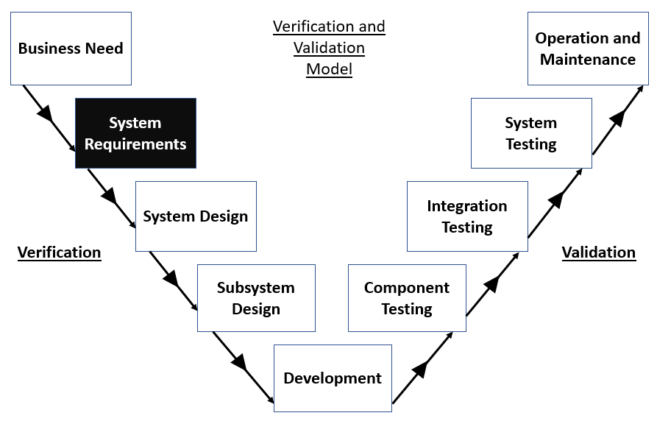

Figure 1: SRD location within the Verification and Validation Model

1. System Requirements

|  |  |  |  |  |  |  |  |
| --- | --- | --- | --- | --- | --- | --- | --- |
| Requirement ID | Requirement | Requirement Type | Threshold Measure of Performance (MOP) | Objective Measure of Performance (MOP) | Validation | Justification and Evidence |  |
| FSN-1 | The System shall comprise of up to 20 sensors. | Functional | The system comprises of 12 sensors (at the minimum) | The system comprises of 20 sensors (at the maximum) | An Inspection is performed to show that the quantity of sensors is in the range specified within the Threshold MOP and the Objective MOP. |  |  |
| FSN-2 | The System shall measure the following variables:   * Footfall * Air Quality * Light Pollution * Traffic Noise | Functional | The system measures the stated variables. | | An Analysis is performed to show that the system measures and outputs data of the stated variables. |  |  |
| FSN-3 | The System shall input data from the variables in FSN-2 into a Data Hub. | Functional | The system components and any 3rd Party data shall be fed into the Data Hub. | | An Analysis is performed to show that the system’s Data Hub collects data from the System Components and any 3rd Party Data. |  |  |
| FSN-4 | The System shall categorise the variables stated in FSN-2 within the Data Hub. | Functional | The Data Hub effectively categorises the 4 measurable variables (stated in FSN-2). | | A Demonstration is performed to show that the Data Hub categorically sorts the 4 variables. |  |  |
| FSN-5 | The System shall output the measurements of the variables stated in FSN-2 on a User Interface. | Human Machine Interface (HMI) | N/A | N/A | An Inspection is performed by the user to show that the system has a functional and interactive display. |  |  |
| FSN-6 | The System shall allow the user to see a timeline of each measured variable. | User Interface | The system allows the user to see measured data over a time span of 3 months. | The system allows the user to see measured data over a time span of 3 weeks. | An Inspection is performed by the user to show that the system can show measured data of all of the variables stated in FSN-2 in the specified timeframes in Threshold and Objective MOP. |  |  |
| FSN-7 | The System shall be able to achieve full functionality within 24 hours of setup. | Functional | The system achieves full operation within 24 hours of setup. | The system achieves full operation within 12 hours of setup. | An Inspection is performed to show that the system achieves full functionality within the timeframes stated in the Threshold and Objective MOP. |  |  |
| FSN-8 | The System shall support 3rd Party data. | Functional | The system can obtain and processing 3rd Party data. | | An Analysis shows that the system obtains and processes 3rd Party data. |  |  |
| FSN-9 | The System shall be able to store data on a server. | Functional | The system is capable of storing collected data on a server. | | A Demonstration is conducted to show that the system is capable of storing collected data (from system components and any 3rd Party data) on a server. |  |  |
| FSN-10 | The System shall be able to operate outdoors. | Performance | The system operates effectively outdoors for 1 week at a time. | The system operates effectively outdoors all the time. | An Inspection is conducted to prove that the system can operate effectively outdoors. |  |  |
| FSN-11 | The System shall be able to withstand all environmental conditions. | Performance | The system operates effectively for 1 week at a time in the following weather conditions:   * Rain (precipitation rate of <4mm/hour) * Wind (average speed per 10m of 7.5 knots) * Snow (up to 5 inches (12.7cm)) | The system operates effectively for 1 week at a time in the following weather conditions:   * Rain (precipitation rate of ≤ 50mm/hour) * Wind (average speed per 10m of 9 knots) * Snow (up to 15 inches (38cm)) | A Demonstration or analysis is conducted to prove that the system can operate effectively in the stated weather conditions. |  |  |
| FSN-12 | The System shall be able to communicate over long distances. | Functional | The system components can communicate over a radius span of 10 miles. | The system components can communicate over a radius span of 50 miles. | An Analysis is conducted to prove that the system components can operate effectively over a range specified between the Threshold MOP and Objective MOP. |  |  |
| FSN-13 | The System shall operate wirelessly. | Functional | The system effectively operates wirelessly within the following frequency bands:   * 868MHz * 2.4GHz (ISM Band) | | A Test or Demonstration is conducted to prove that the system can operate wirelessly within the stated frequency bands. |  |  |
| FSN-14 | The System shall operate within the range of -20°C to 50°C. | Performance | The system can effectively operate within the stated temperature range for days at a time. | The system can effectively operate within the stated temperature range all the time. | A Demonstration or Analysis is conducted to prove that the system can operate effectively in the stated temperature range. |  |  |
| FSN-15 |  |  |  |  |  |  |  |
| FSN-16 | The System shall not obstruct pedestrian and vehicular right-of-way. |  |  |  |  |  |  |
| FSN-17 | The System shall be able to attach to external structures |  |  |  |  |  |  |
| FSN-18 | The System shall not be permanently fixed to external structures |  |  |  |  |  |  |
| FSN-19 | The System shall be maintainable by all members of Team Fusion. |  |  |  |  |  |  |
| FSN-20 |  |  |  |  |  |  |  |
| FSN-21 |  |  |  |  |  |  |  |
| FSN-22 |  |  |  |  |  |  |  |
| FSN-23 |  |  |  |  |  |  |  |

***End of Document***